*SAFE CARZ*

*INSURANCE*

DEVELOPER GUIDE

|  |  |
| --- | --- |
| Batch Information | |
| Faculty | Sir Taha Abbas |
| Coordinater | Miss Maham Haider |
| Batch No | 2409E2(T,T,S) |

|  |  |
| --- | --- |
| E Project | Insurance |
| Group | C |
| Group Members | |
| ID Number | Name |
| Student1605829 | KASHAF AKHLAQ .(Leader) |
| Student1605688 | MUHAMMAD FARAZ . |
| Student1605995 | ZILL E HUMA . |
| Student1605660 | MUHAMMAD ABDUL REHMAN . |



* INDEX PAGE

NAVBAR SECTION



NAVBAR CODE

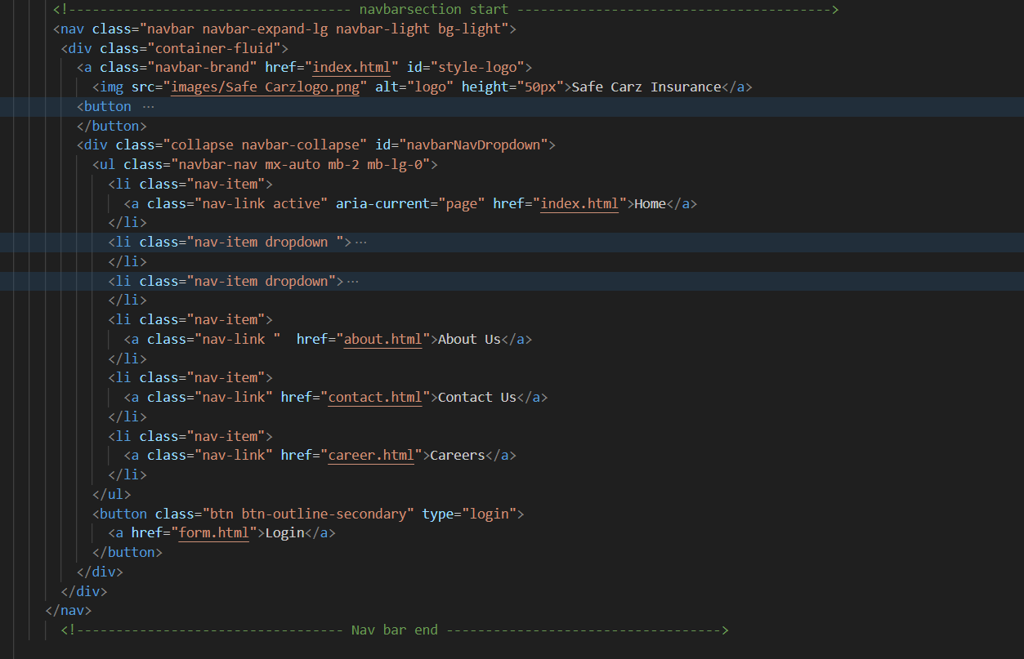

HEADER SECTION



HEADER SECTION CODE

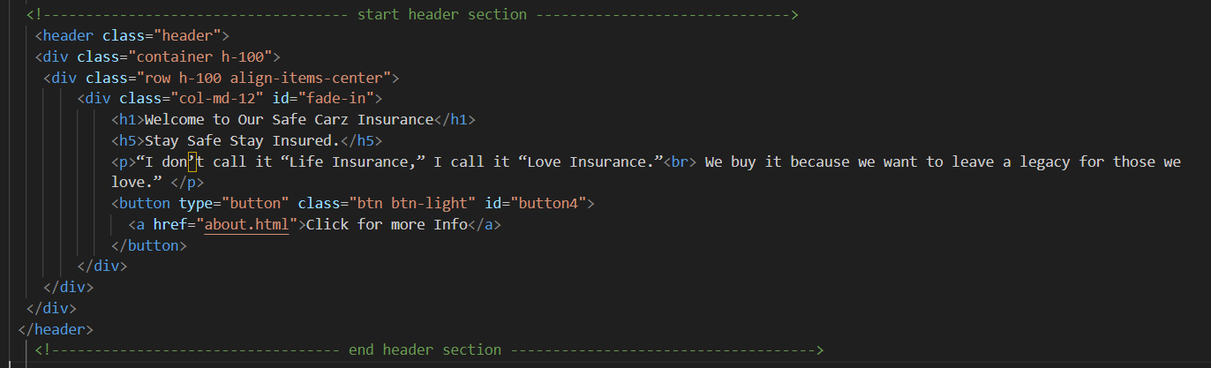

COMPANY SECTION

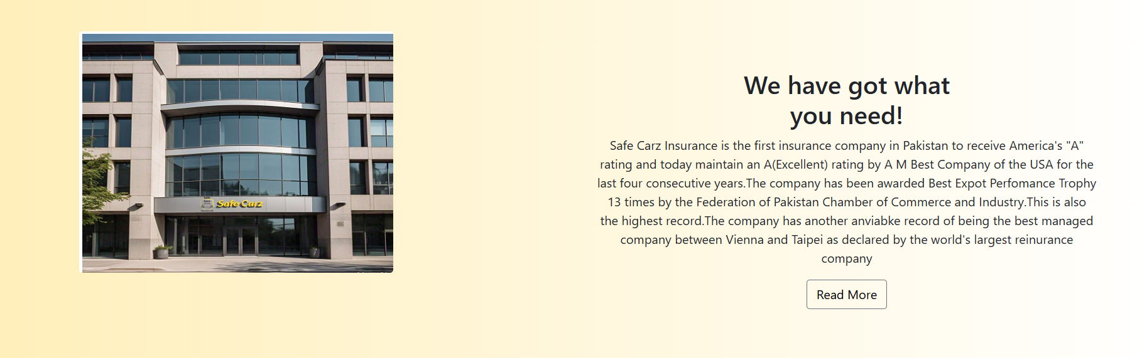

COMPANY SECTION CODE

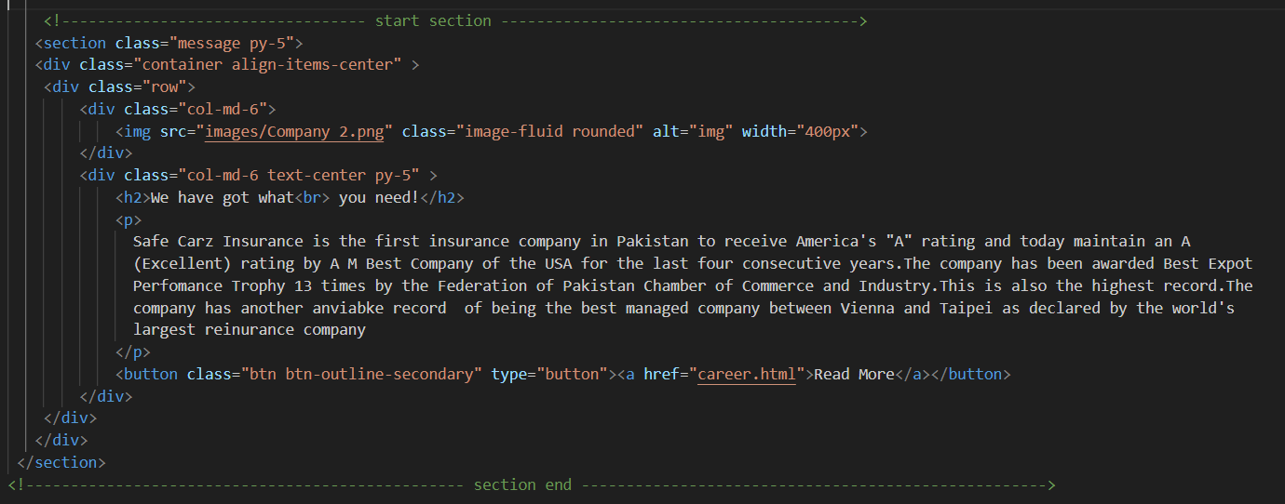

SERVICES SECTION

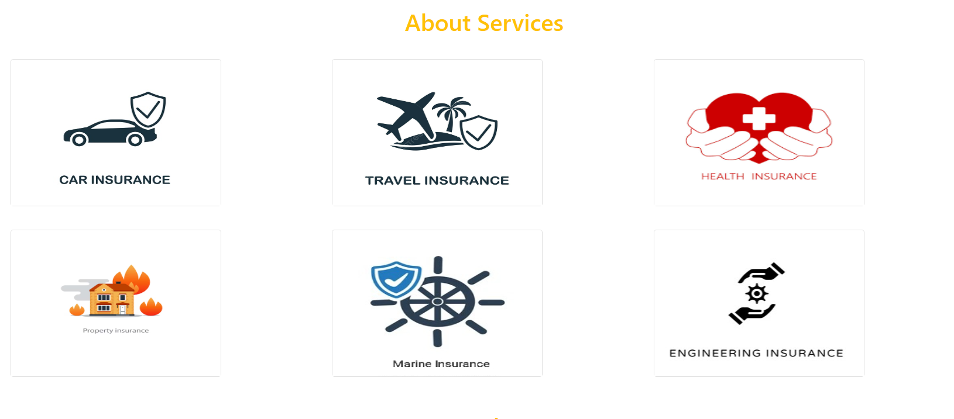

SERVICES CODE

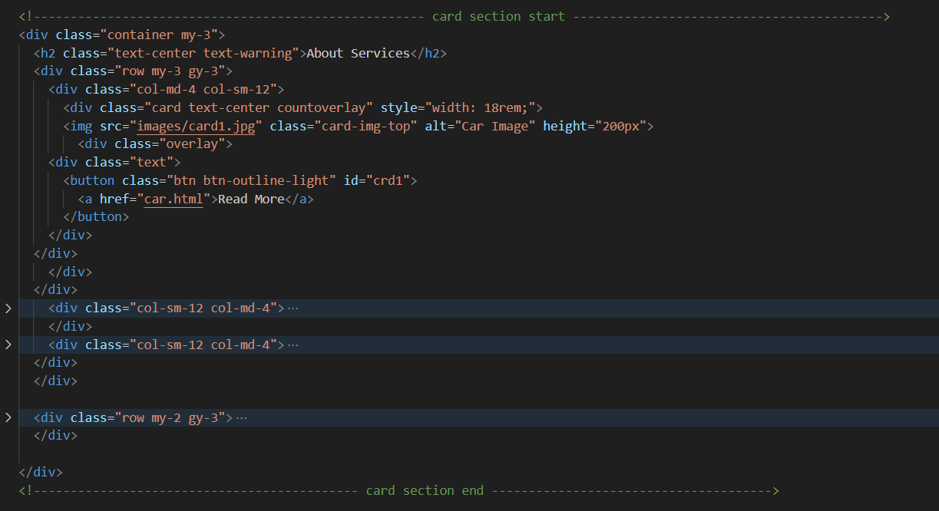

PARTENERS SECTION



PARTENERS SECTION CODE

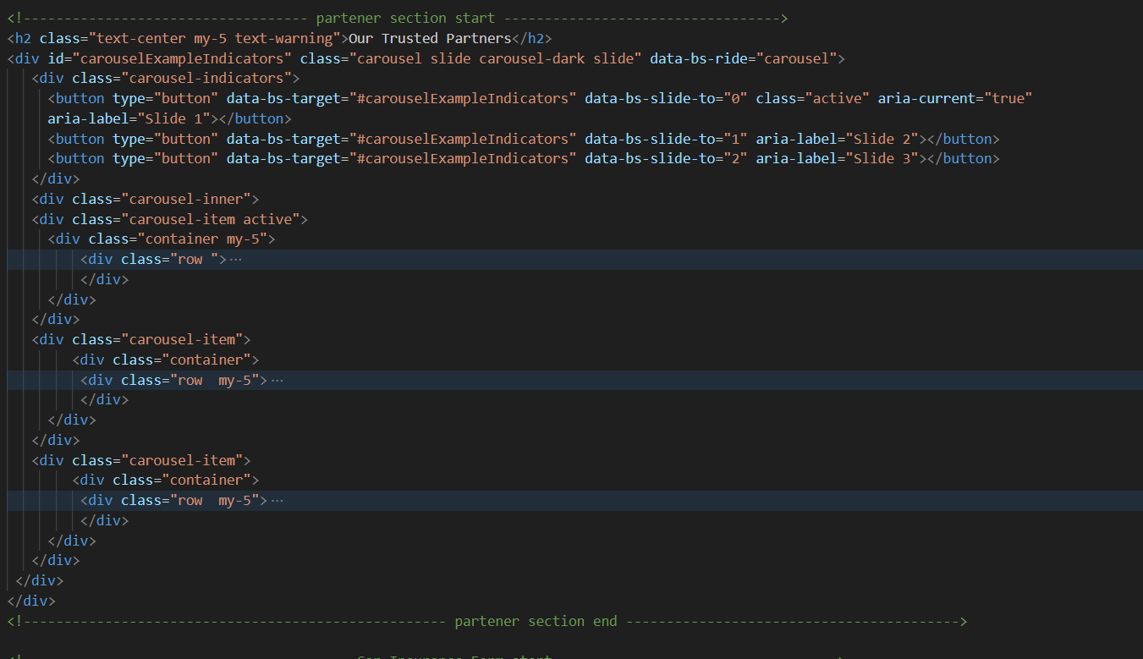

INSURANCE FORM SECTION

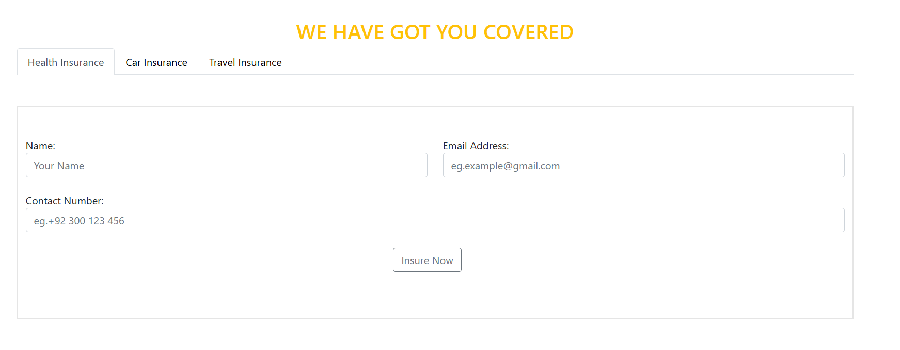

INSURANCE FORM CODE

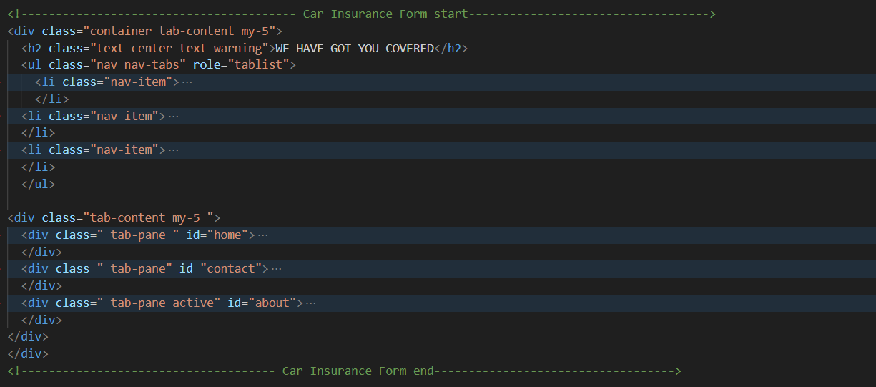

QUERY SECTION

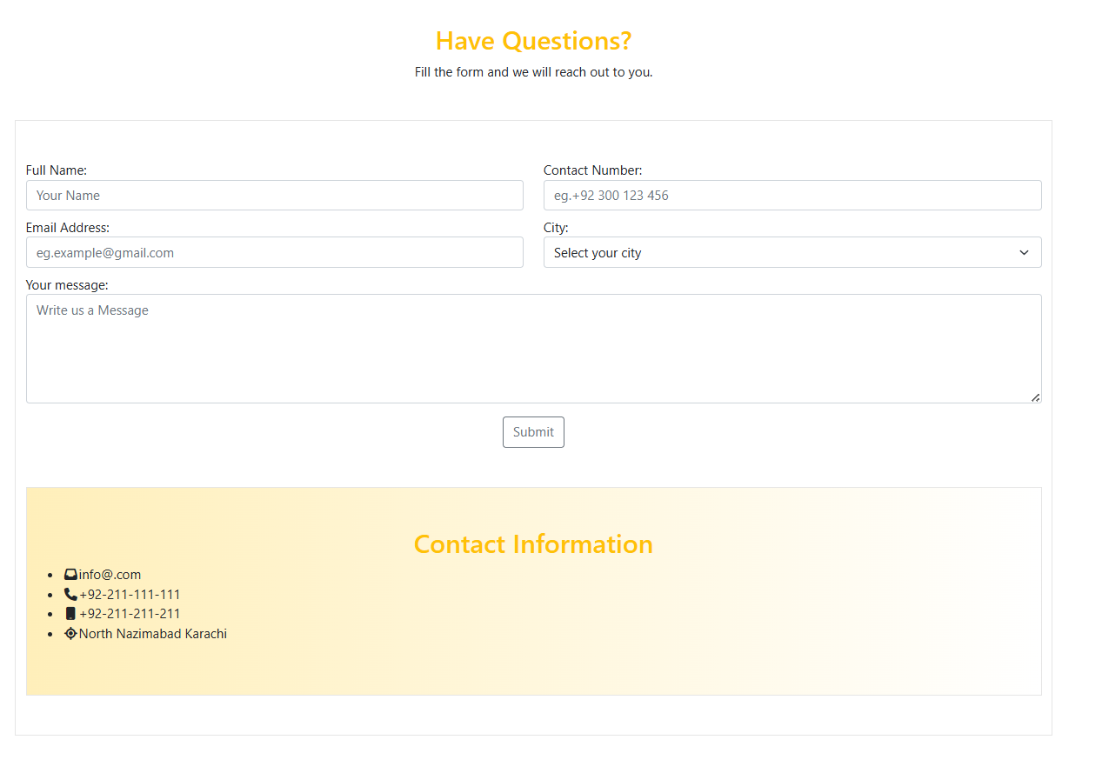

QUERY SECTION CODE

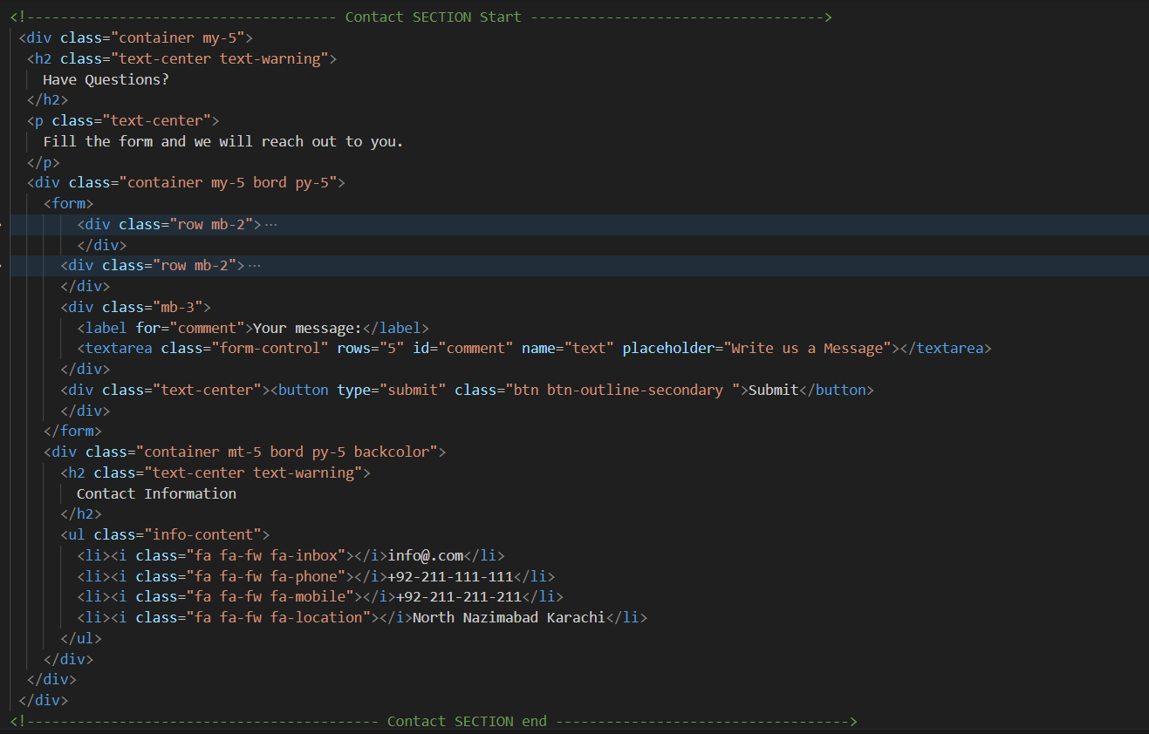

TESTIMONIALS SECTION



TESTIMONIALS CODE

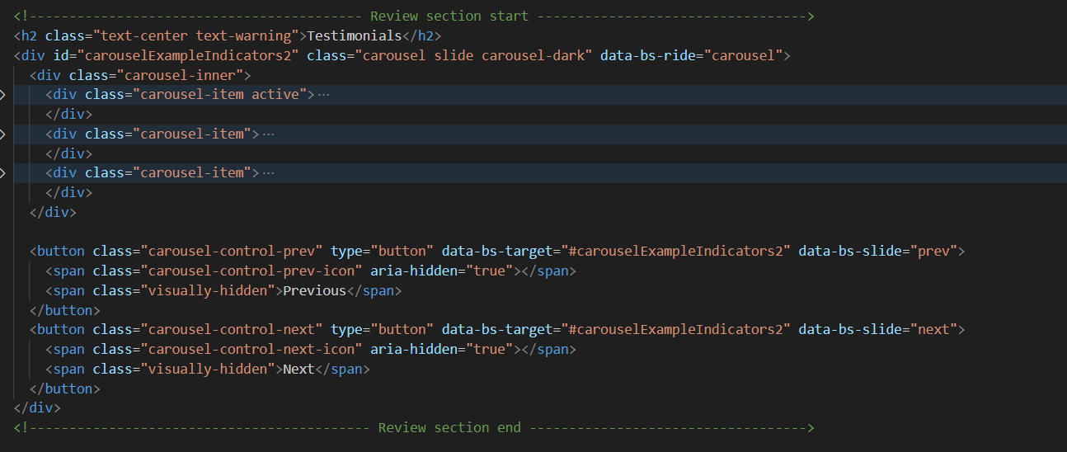

DOWNLOAD AND RATING SECTION



DOWNLOAD AND RATING SECTION CODE

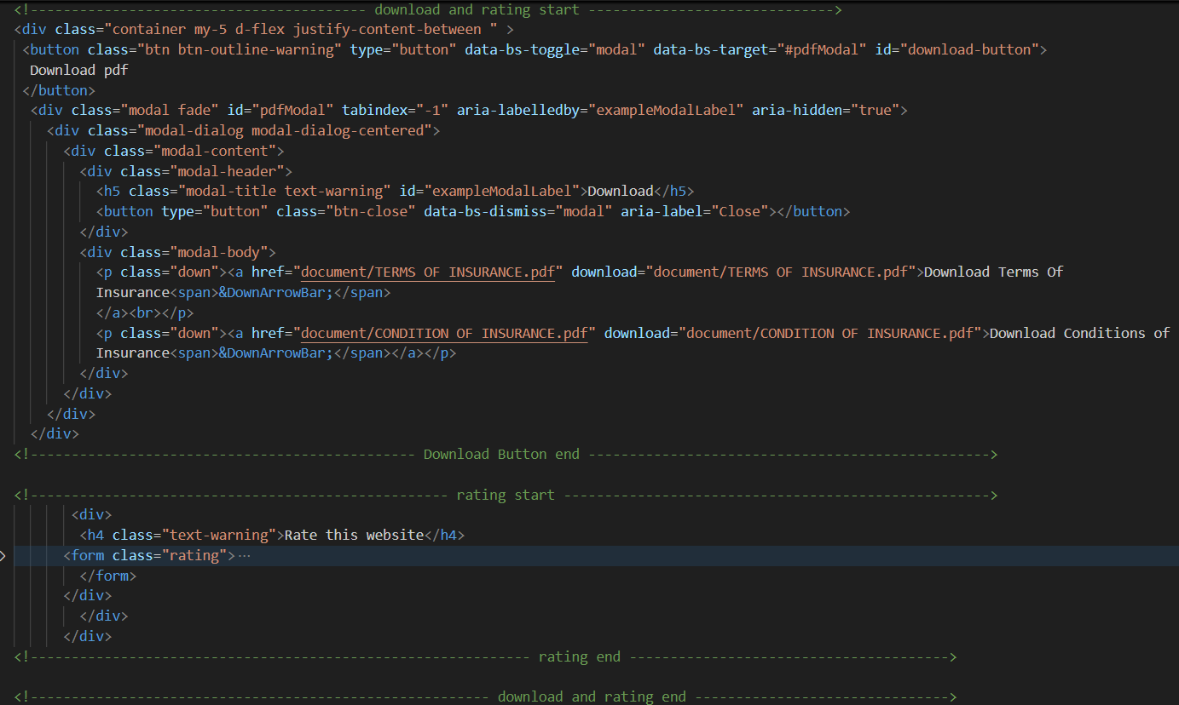

FOOTER SECTION

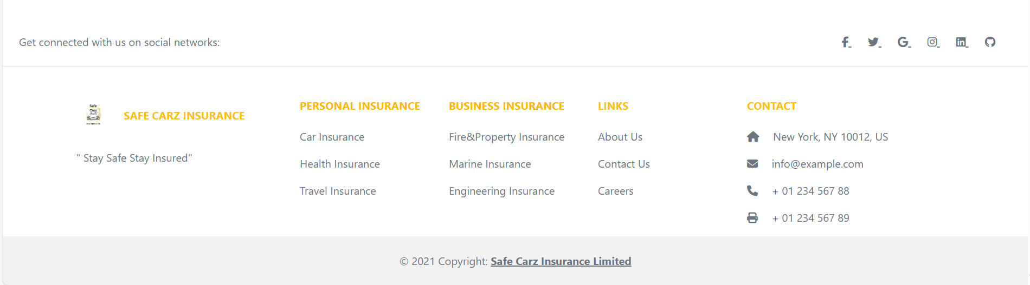

FOOTER SECTION CODE

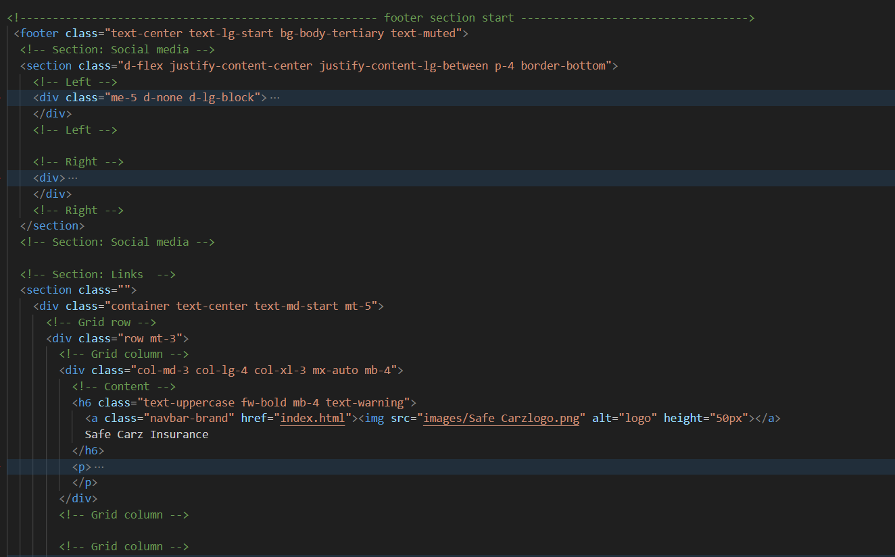 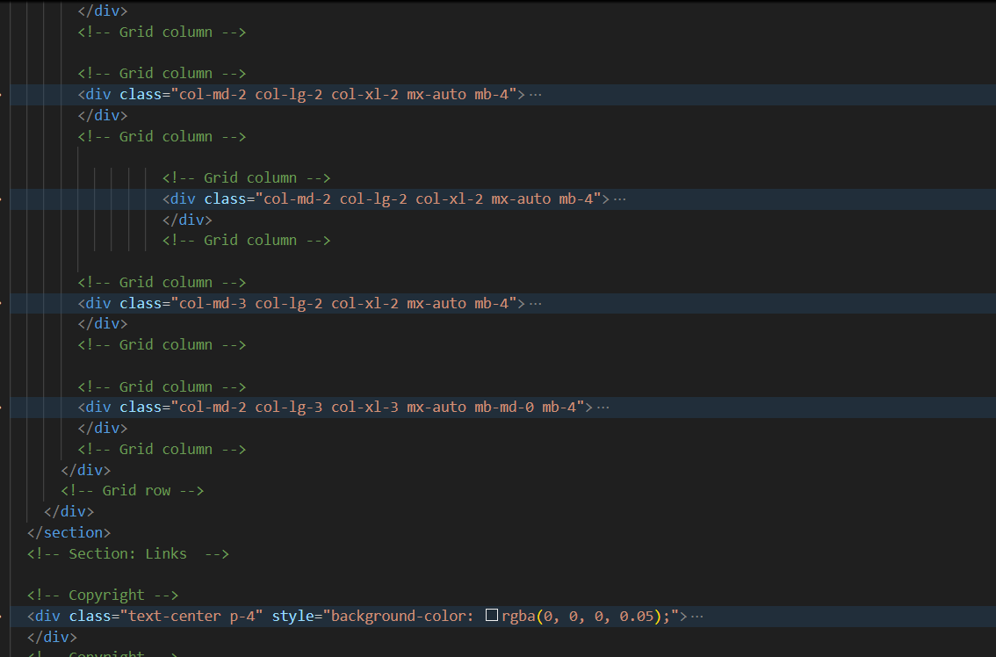 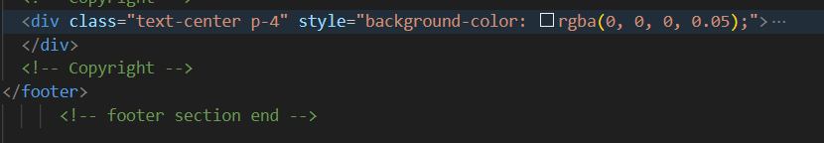

* PERSONAL INSURANCE PAGE

HEADER SECTION



HEADER SECTION CODE

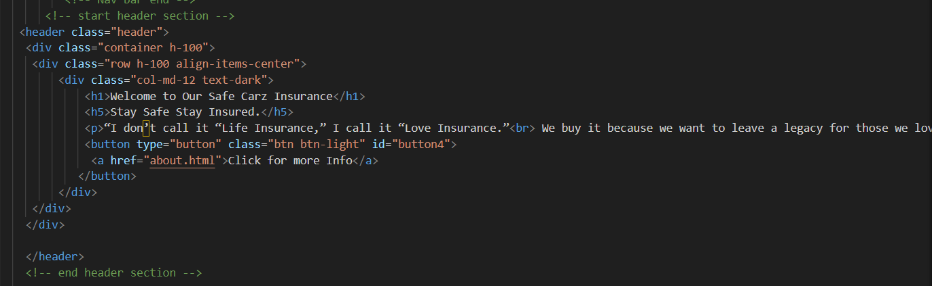

PRODUCTS SECTION

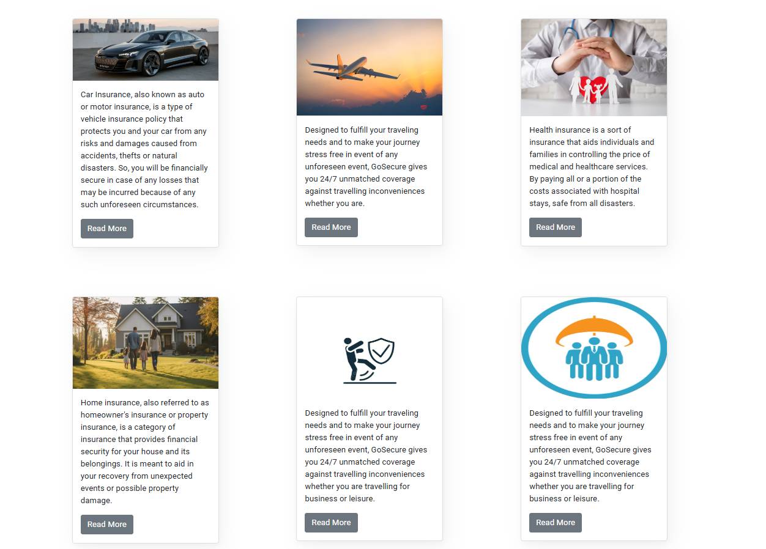

PRODUCT SECTION CODE

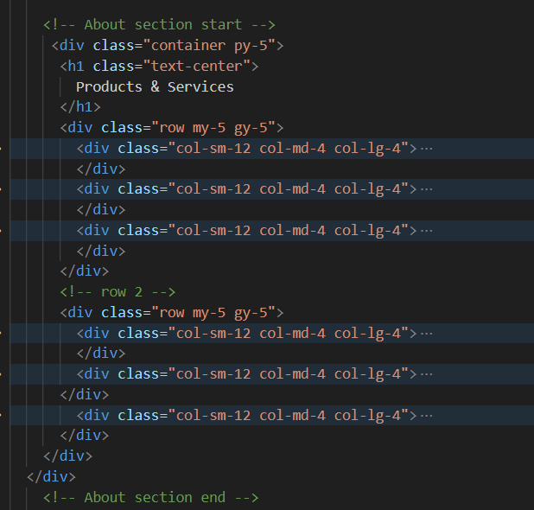

CLAIM SECTION



CLAIM SECTION CODE

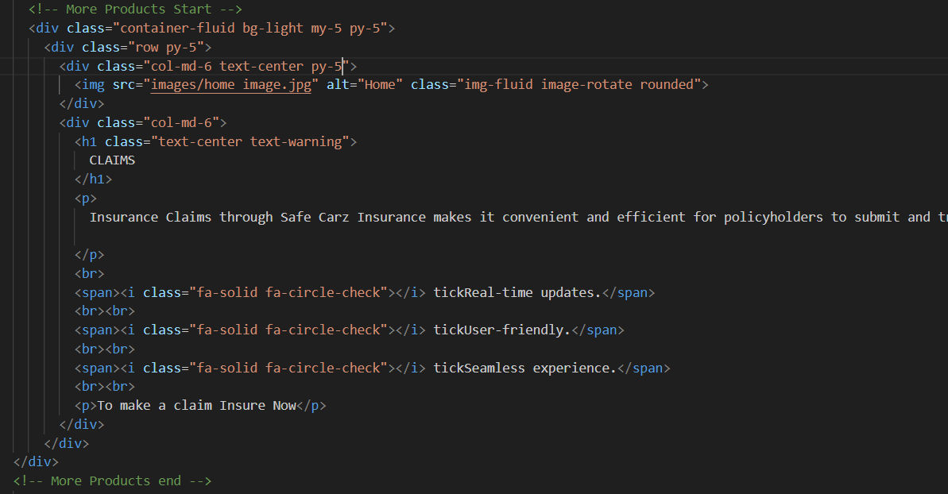

QUESTION SECTION

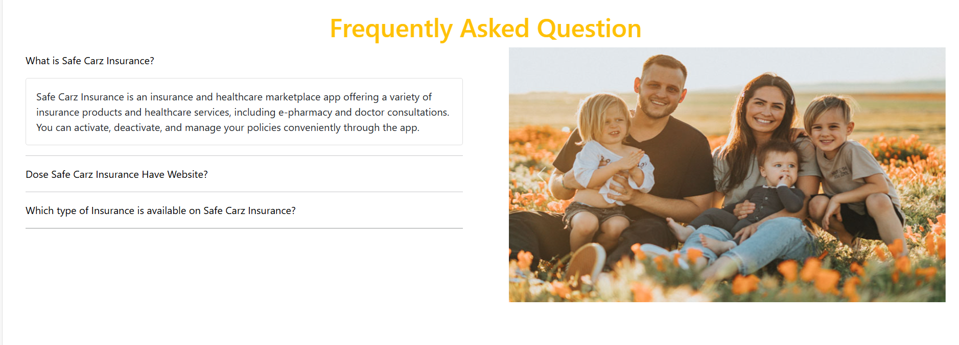

QUESTION SECTION CODE

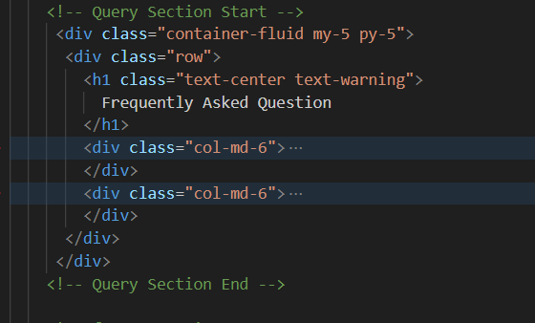

* CAR INSURANCE

HEADER SECTION



HEADER SECTION CODE

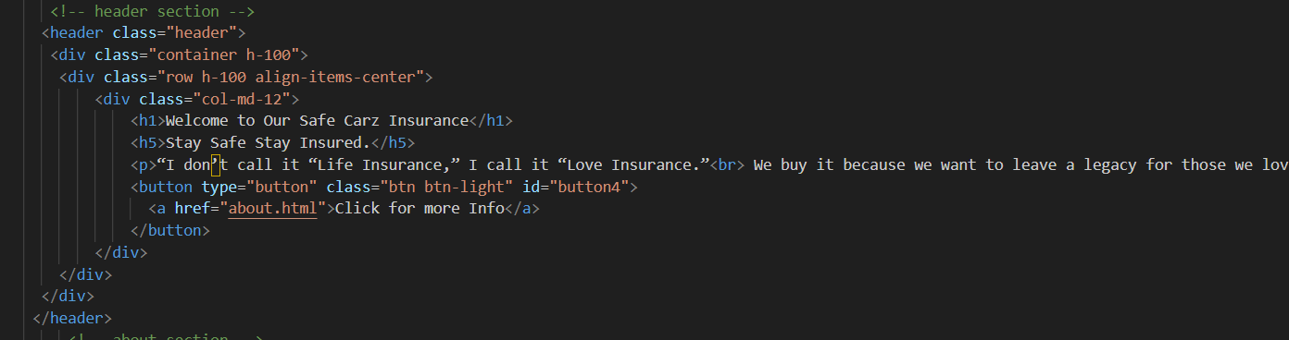

CAR IFORMATION SECTION

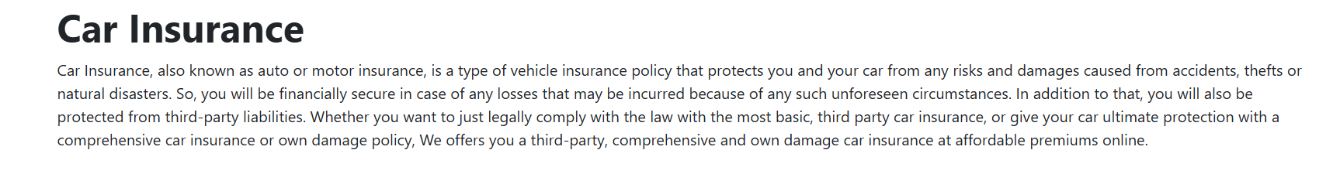

CAR IFORMATION SECTION CODE

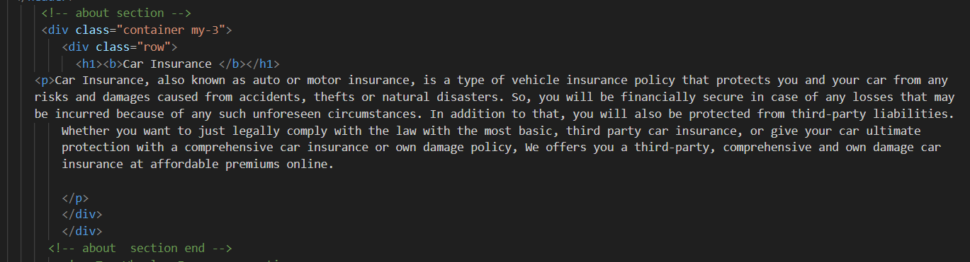

BIKE HEADER SECTION

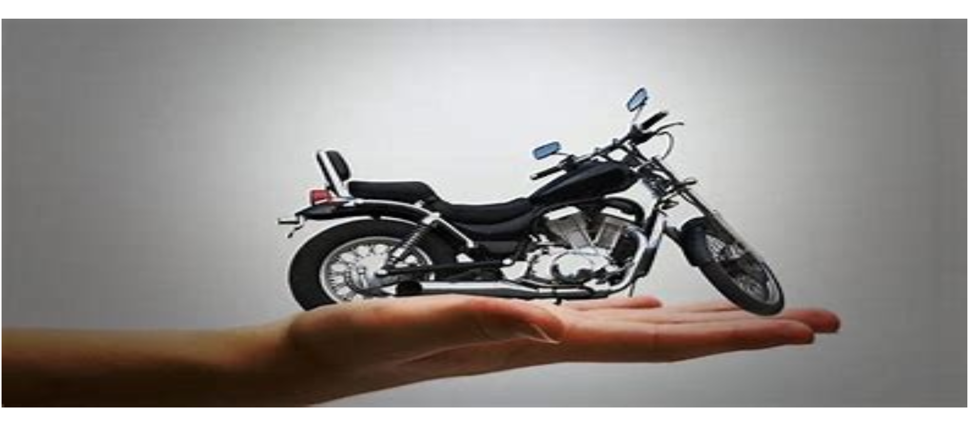

BIKE HEADER SECTION CODE

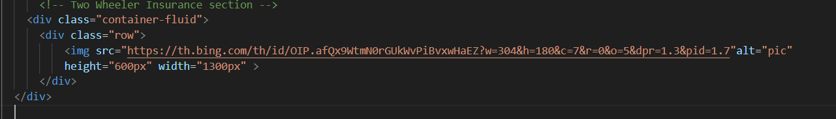

BIKE CATEGORIES SECTION

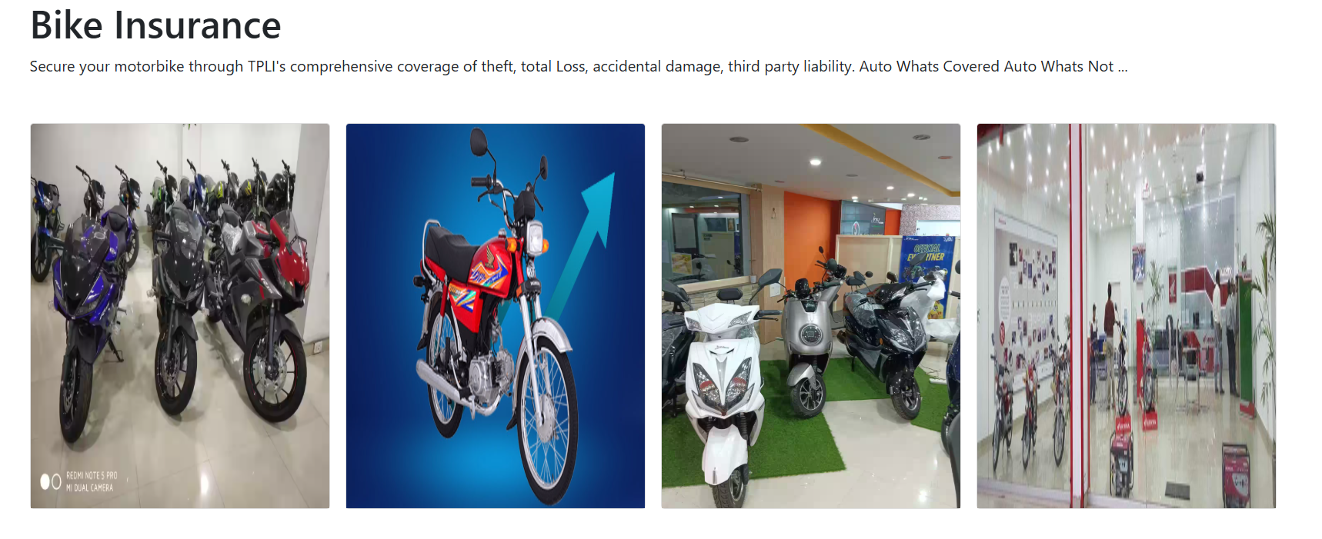

BIKE CATEGORIES SECTION CODE

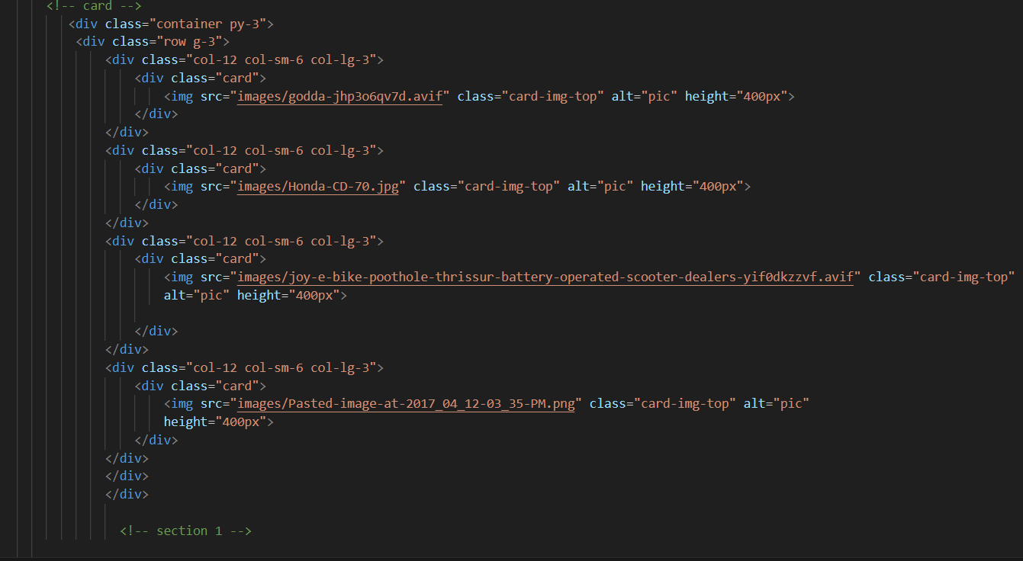

IMPORTANCE OF SAFE CARZ ISURANCE SECTION

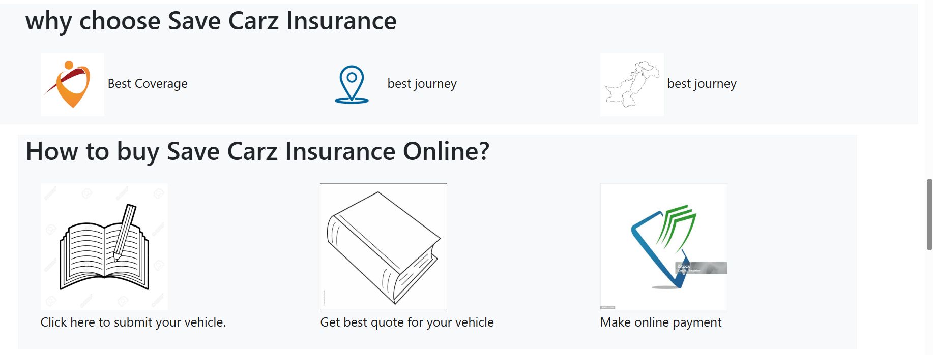

IMPORTANCE OF SAFE CARZ ISURANCE SECTION CODE

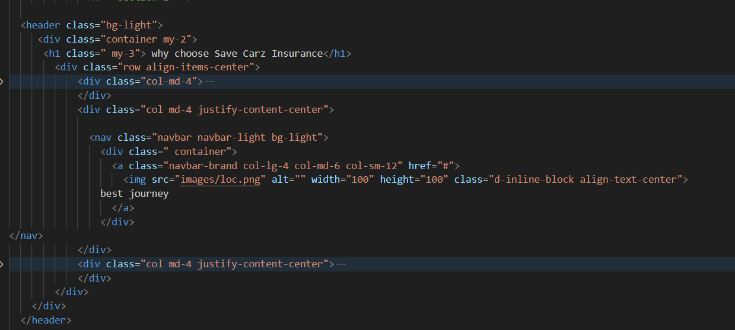

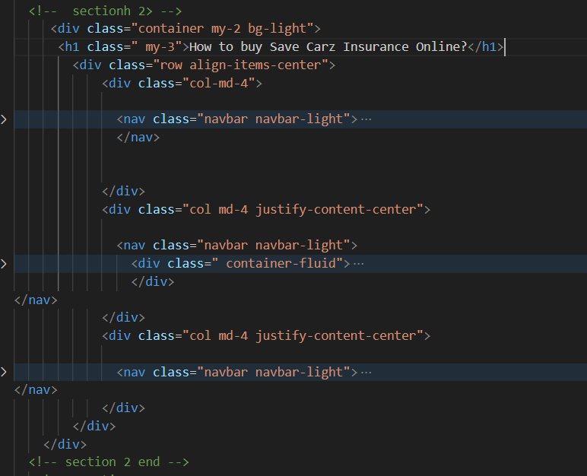

QUERY SECTION



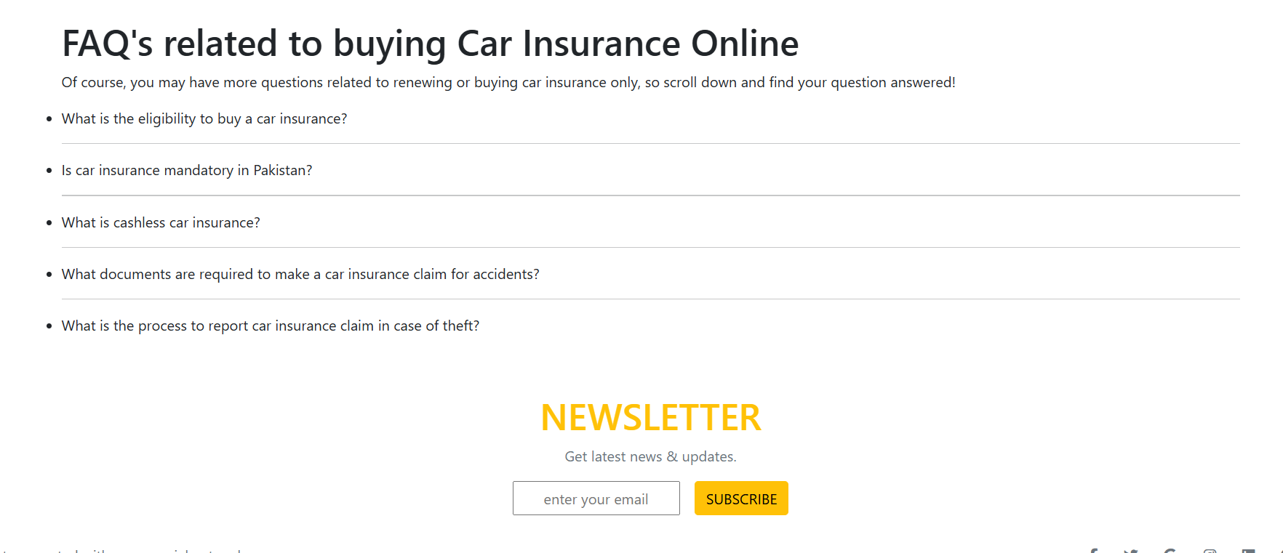

QUERY SECTION CODE

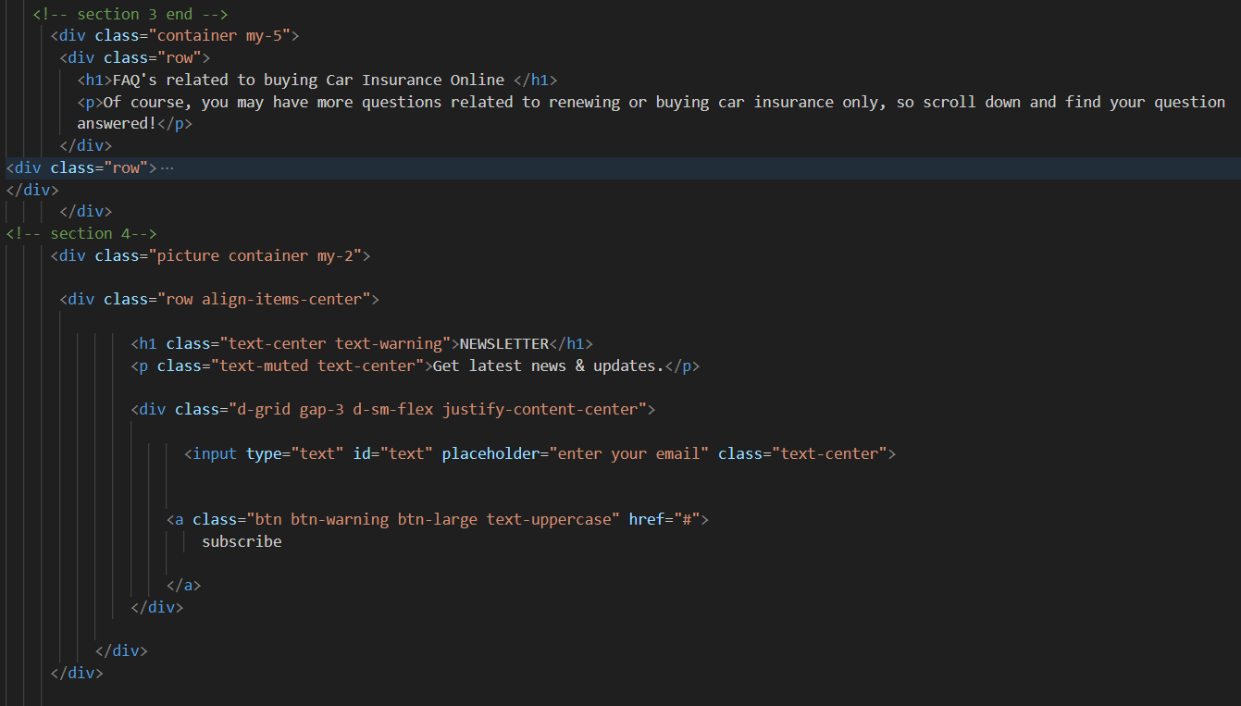

* TRAVEL INSURANCE

HEADER SECTION



HEADER SECTION CODE



TRAVEL INFORMATION SECTION



TRAVEL IFORMATION SECTION CODE

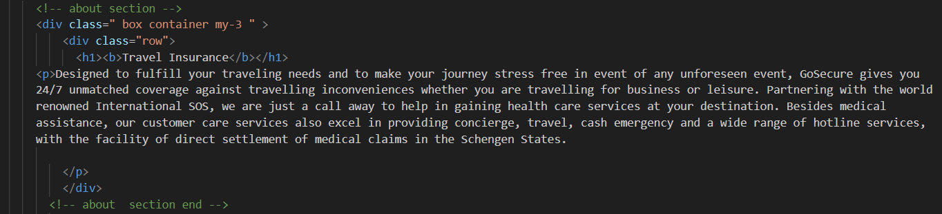

IMPORTANCE OF SAFE CARZ ISURANCE SECTION



IMPORTANCE OF SAFE CARZ ISURANCE SECTION CODE





QUERY SECTION

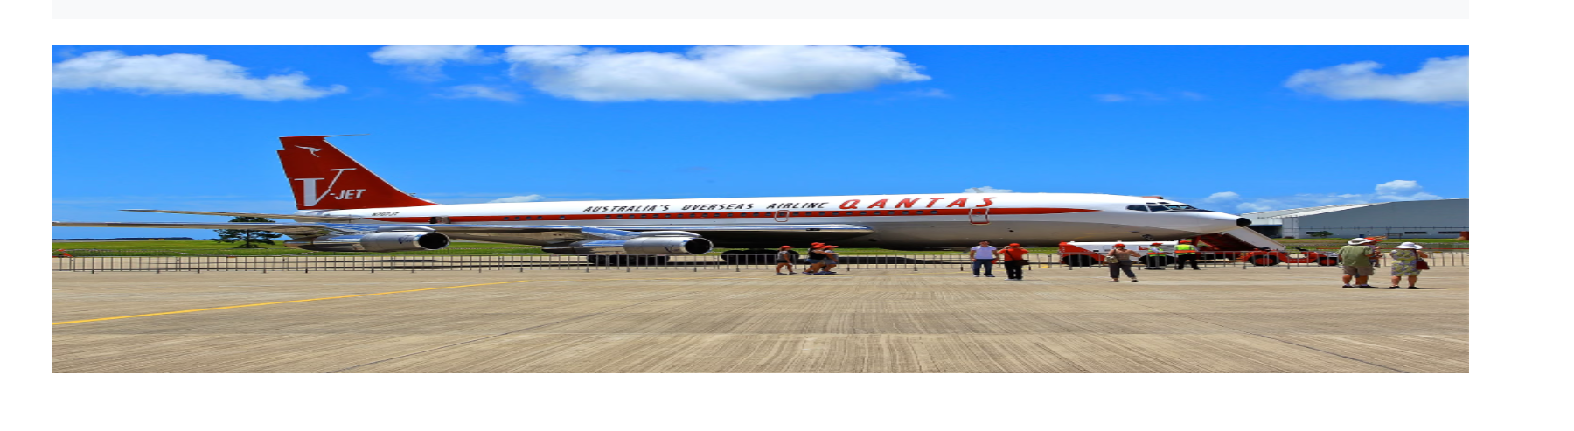



QUERY SECTION CODE



* HEALTH INSURANCE

HEADER SECTION



HEADER SECTION CODE



HEALTH INFORMATION SECTION

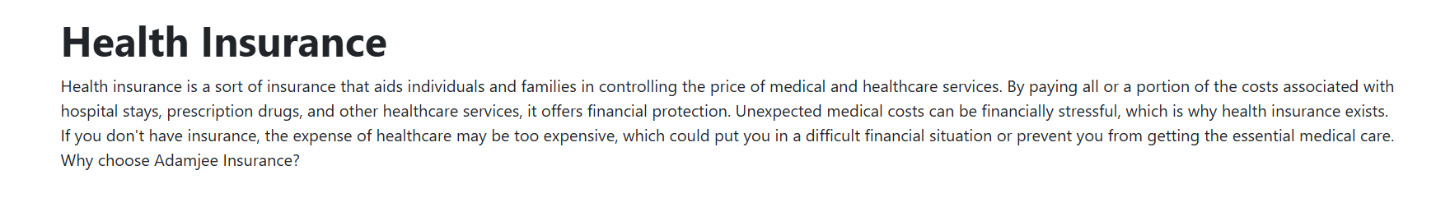

HEALTH IFORMATION SECTION CODE



IMPORTANCE OF SAFE CARZ ISURANCE SECTION



IMPORTANCE OF SAFE CARZ ISURANCE SECTION CODE





QUERY SECTION



QUERY SECTION CODE



* BUSINESS INSURANCE PAGE

HEADER SECTION



HEADER SECTION CODE



PRODUCTS SECTION

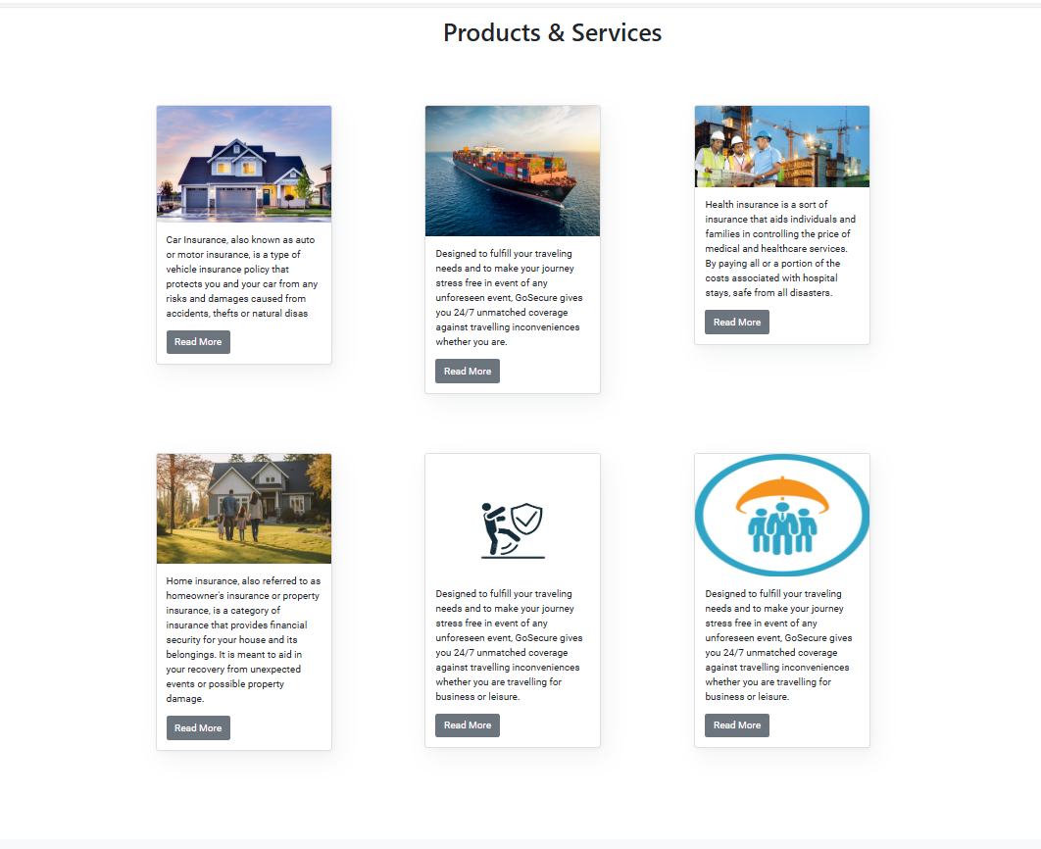

PRODUCT SECTION CODE



PRODUCTS INFORMATION SECTION

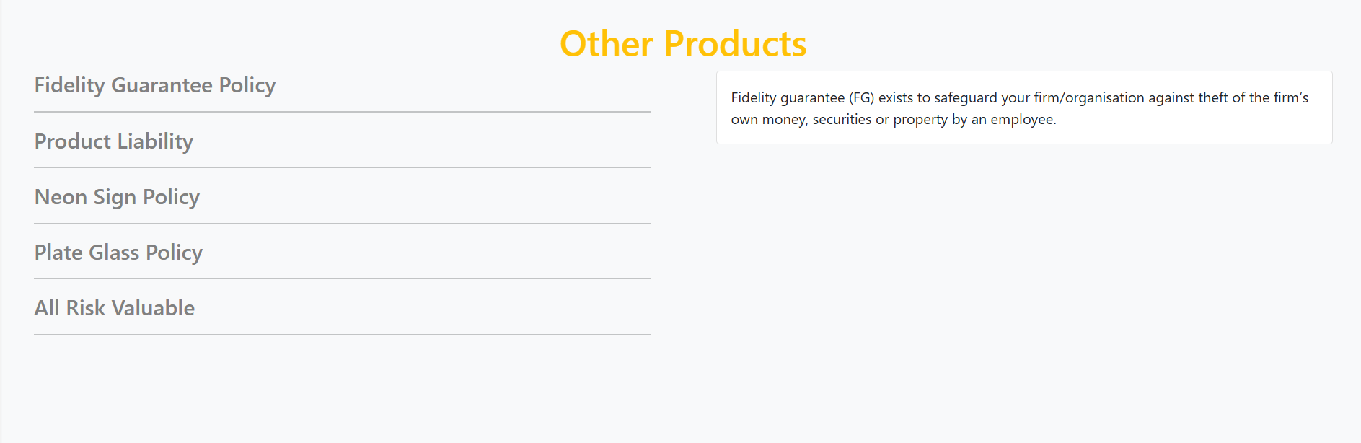

PRODUCT INFORMATION SECTION CODE

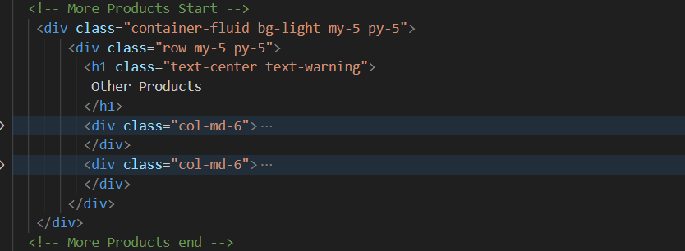

QUESTION SECTION

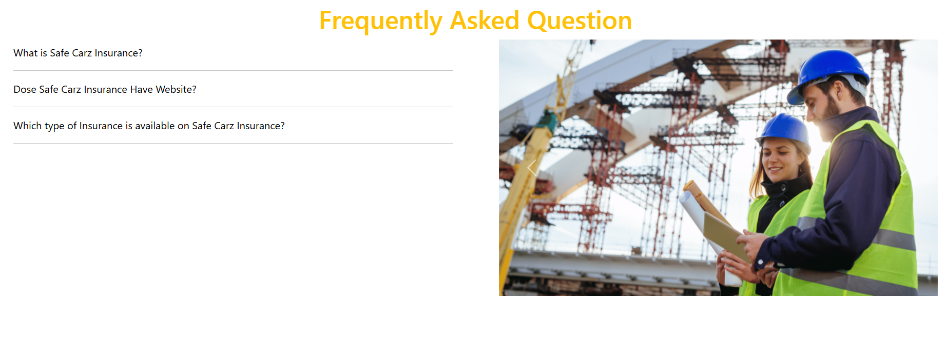

QUESTION SECTION CODE



* PROPERTY INSURANCE

HEADER SECTION



HEADER SECTION CODE



HOME INFORMATION SECTION

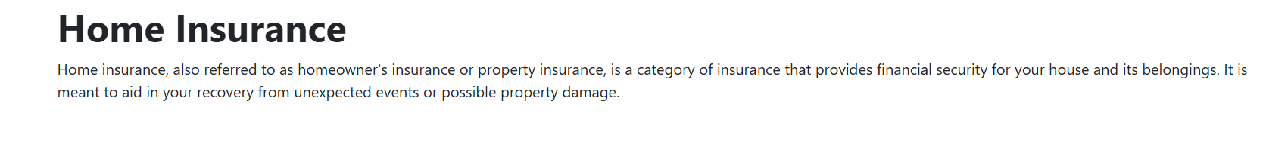

HOME IFORMATION SECTION CODE

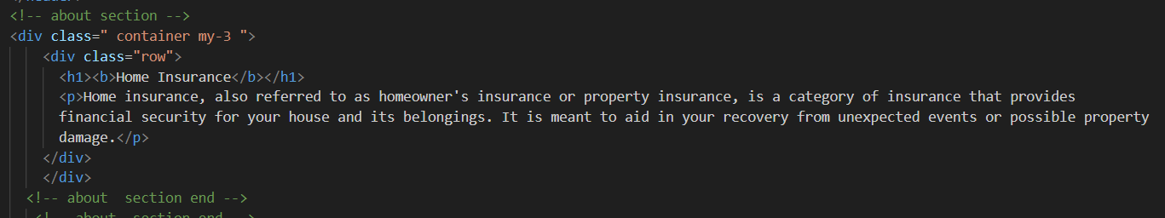

IMPORTANCE OF SAFE CARZ ISURANCE SECTION



IMPORTANCE OF SAFE CARZ ISURANCE SECTION CODE





QUERY SECTION



QUERY SECTION CODE



* MARINE INSURANCE

HEADER SECTION



HEADER SECTION CODE



MORE INFORMATION

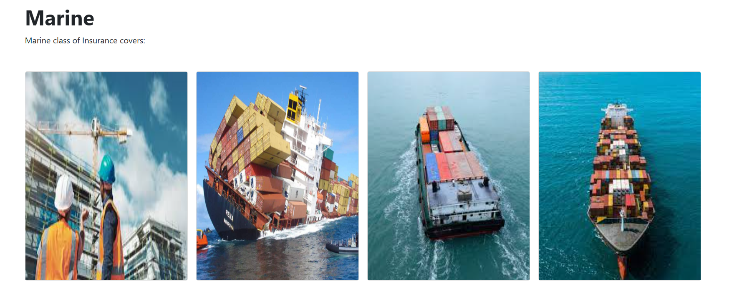

MORE INFORMATION CODE

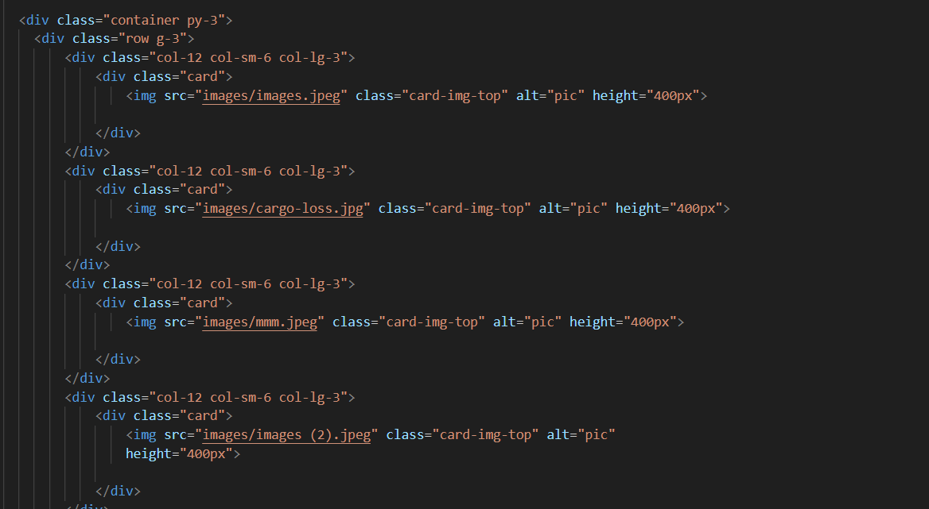

ACTIVATION

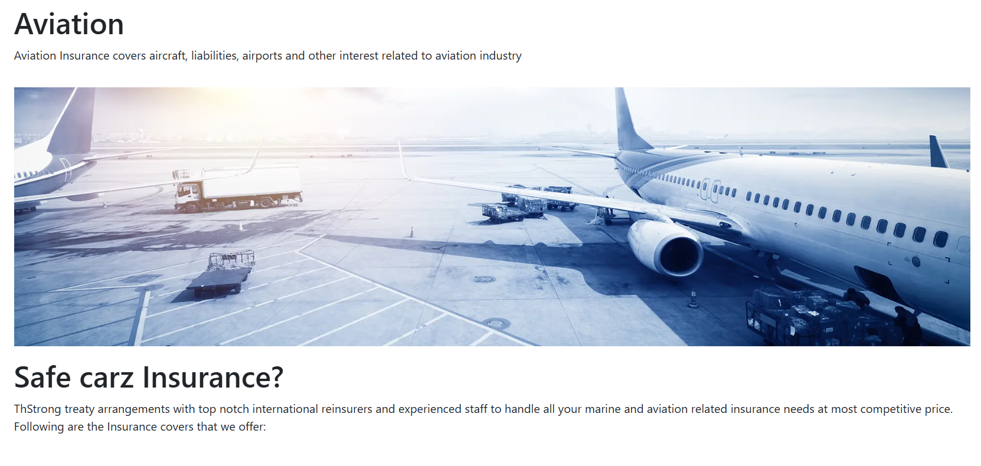

ACTIVATION CODE

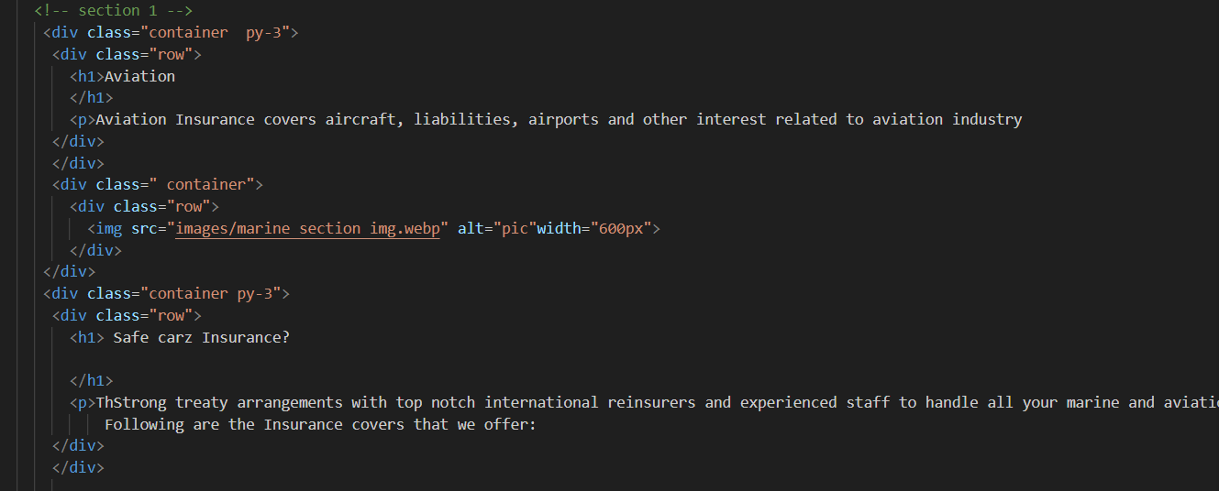

MORE INFORMATION

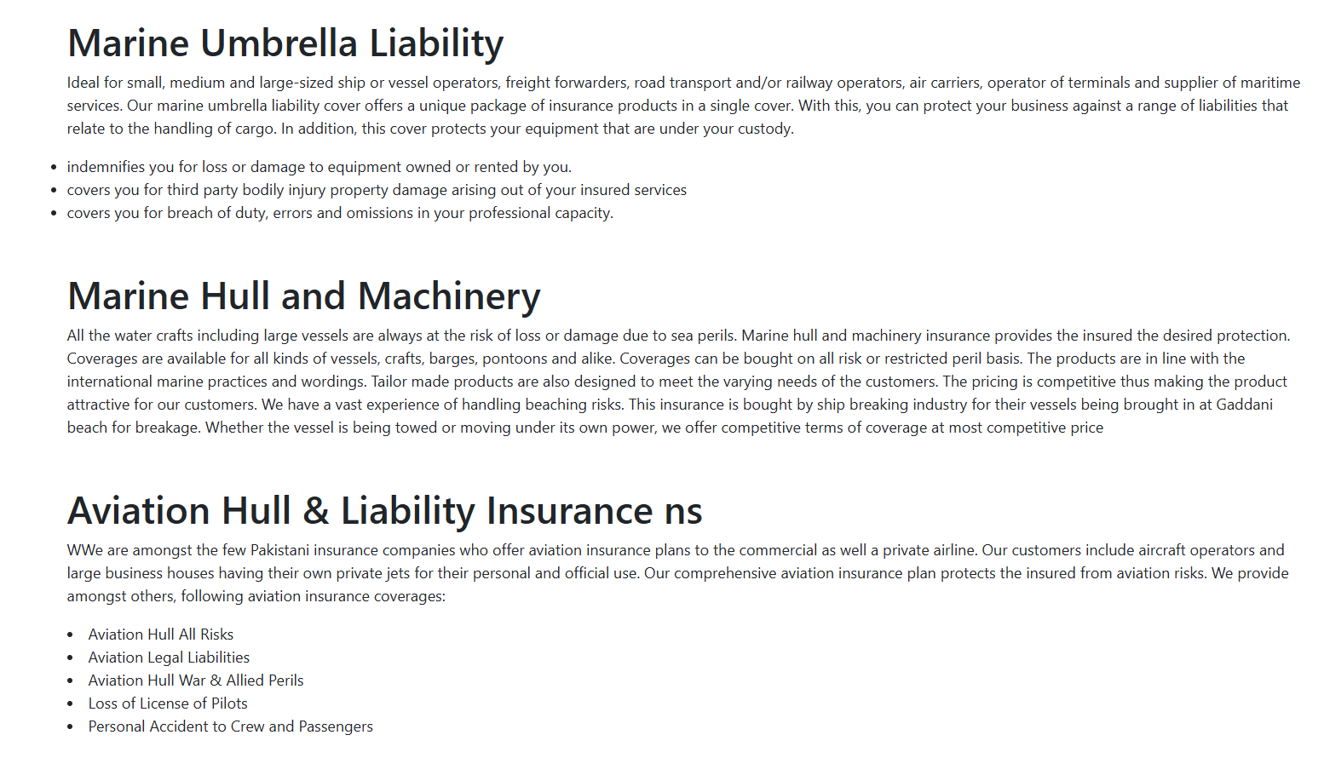

NEWSLETTER



* ENGINEERING INSURANCE

HEADER SECTION



HEADER SECTION CODE



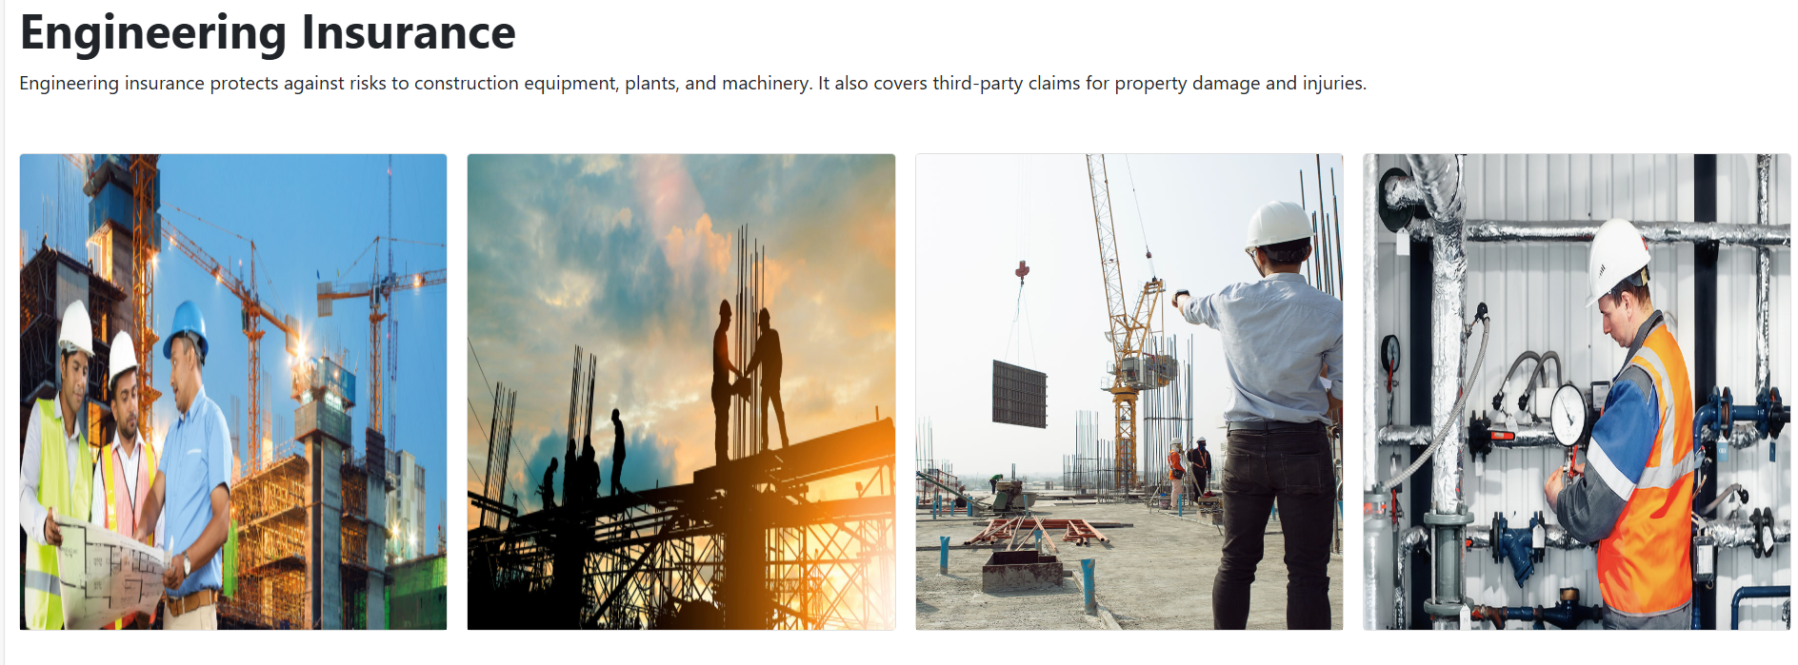

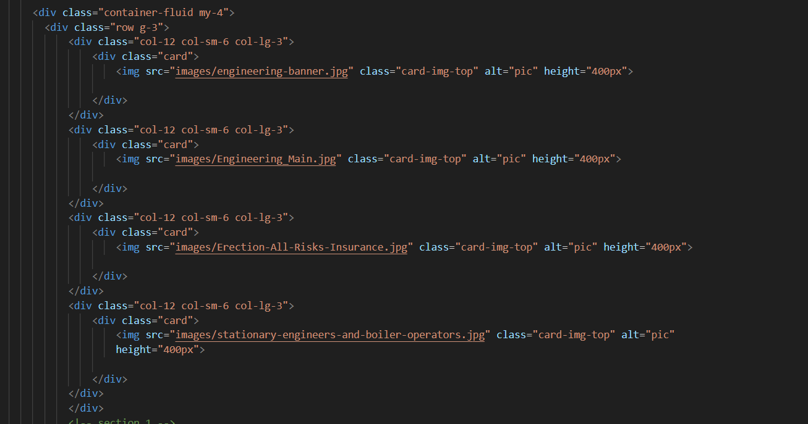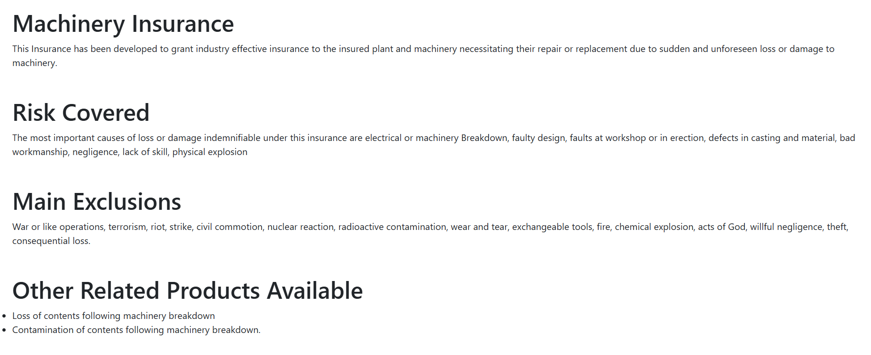

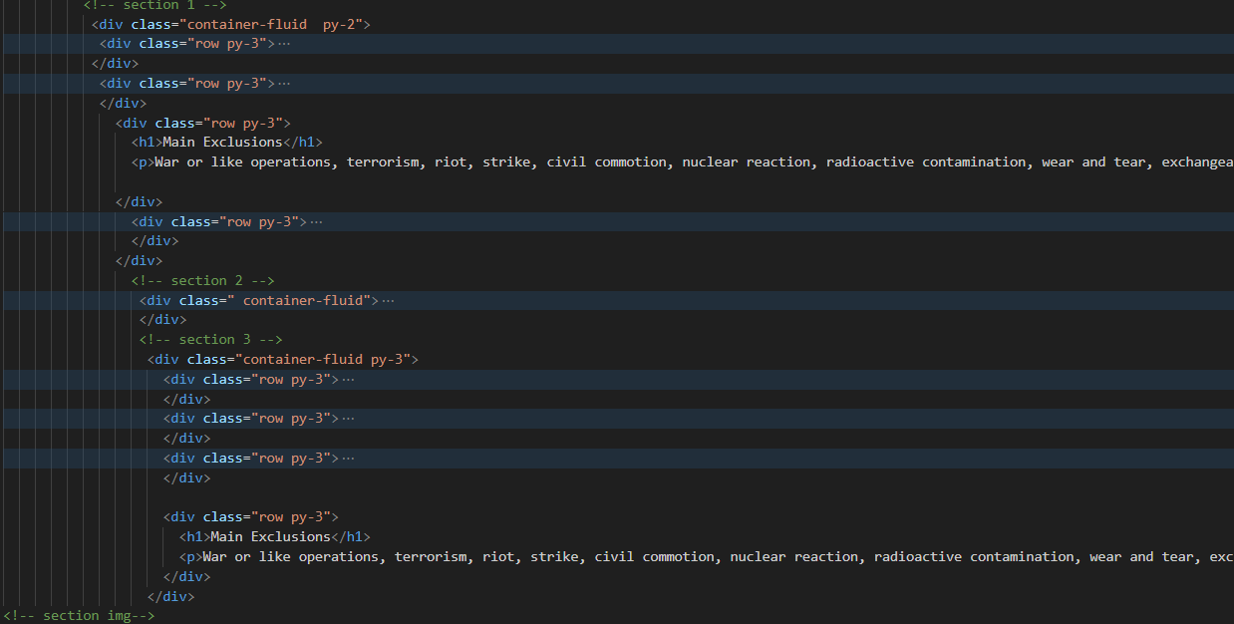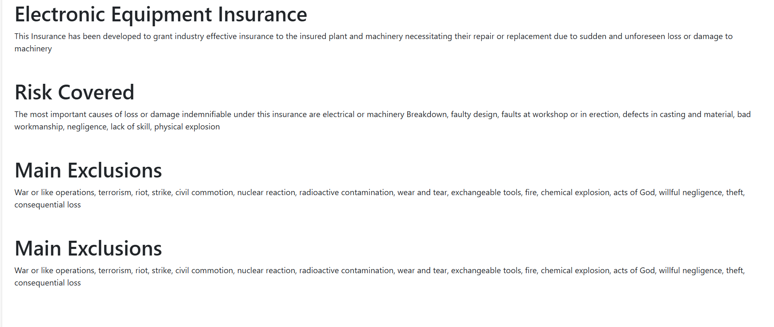

* About us Page

HEADER SECTION



HEADER SECTION CODE

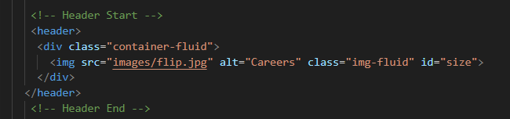

OVERVIEW SECTION

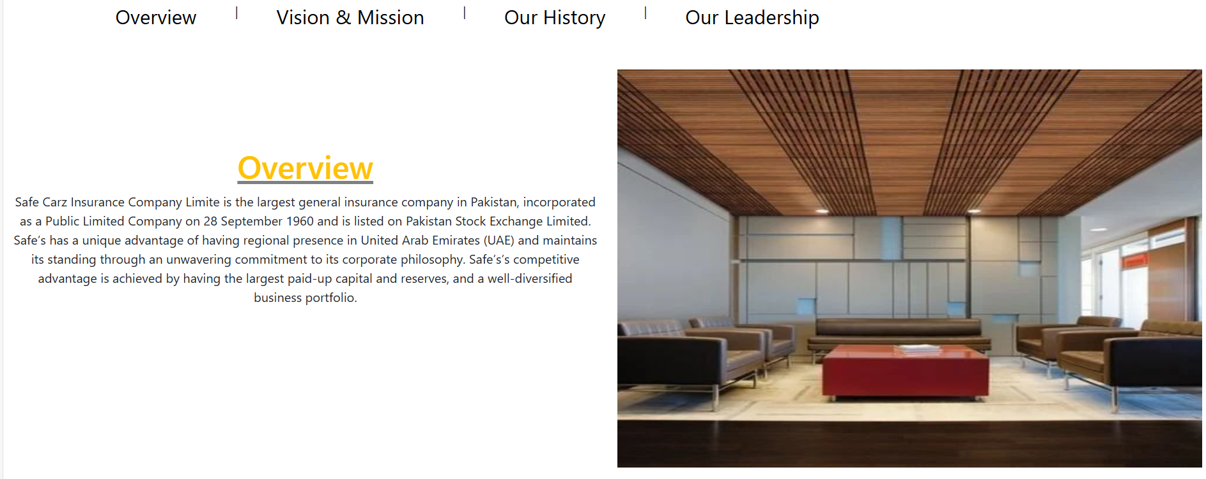

OVERVIEW SECTION CODE

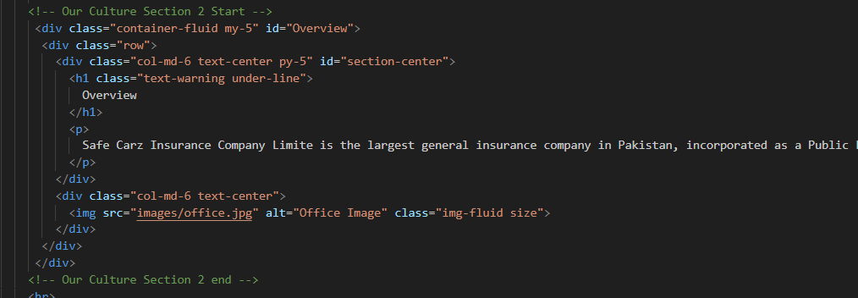

DYNAMIC SETTING



DYNAMIC SETTING CODE

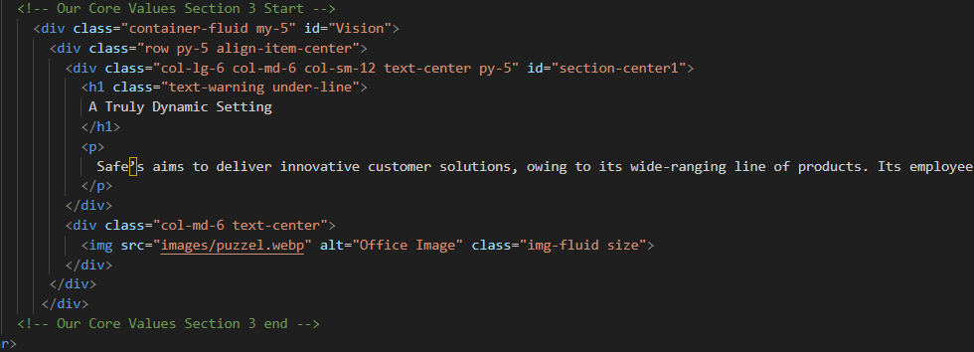

DELIVERING VLUE TO CUSTOMER



DELIVERING VLUE TO CUSTOMER CODE

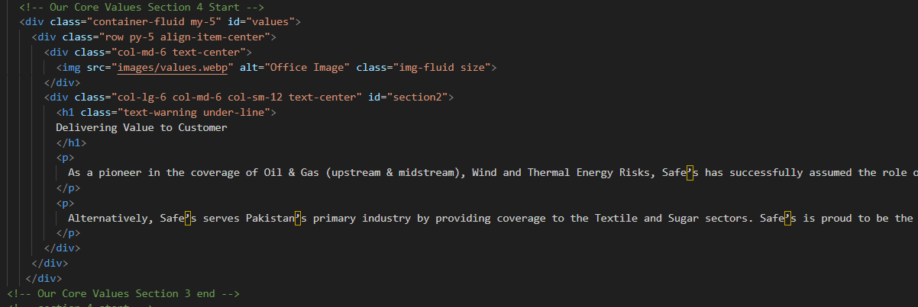

VISION SECTION



VISION SECTION CODE

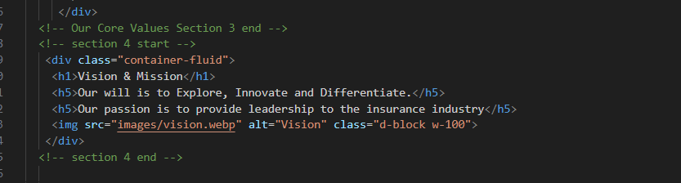

* CONTACT PAGE



LOCATION OF OFFICES



LOCATION OF OFFICES CODE

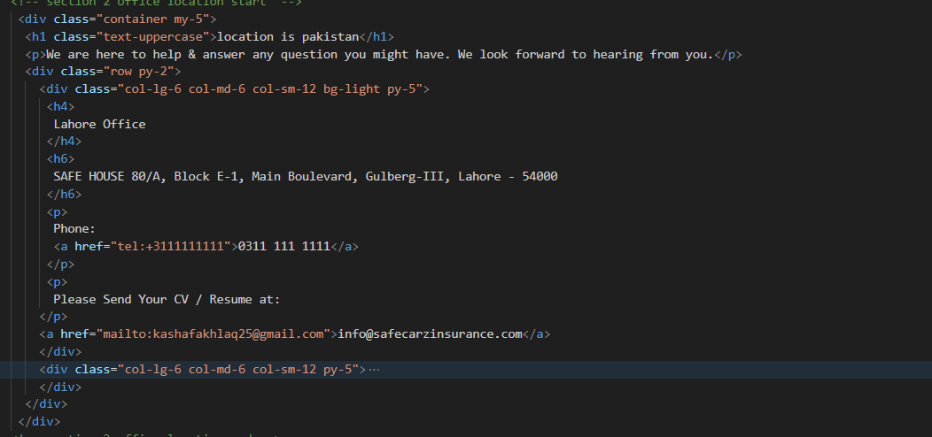

FORM SECTION

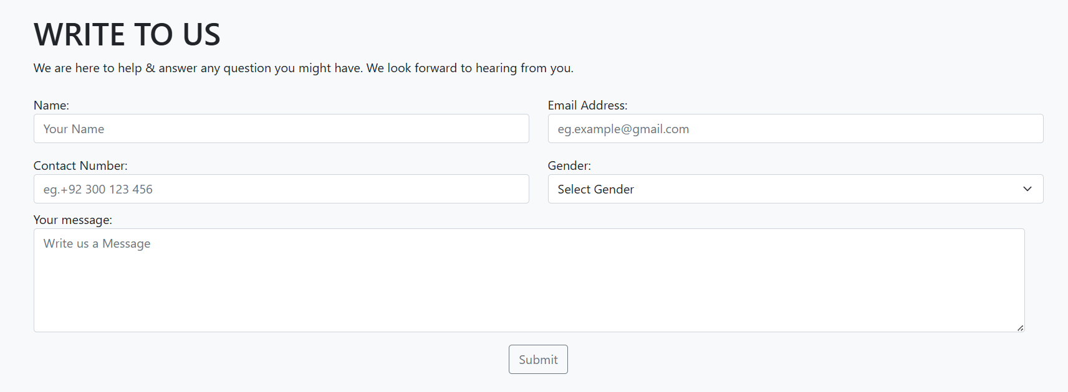

FORM SECTION CODE

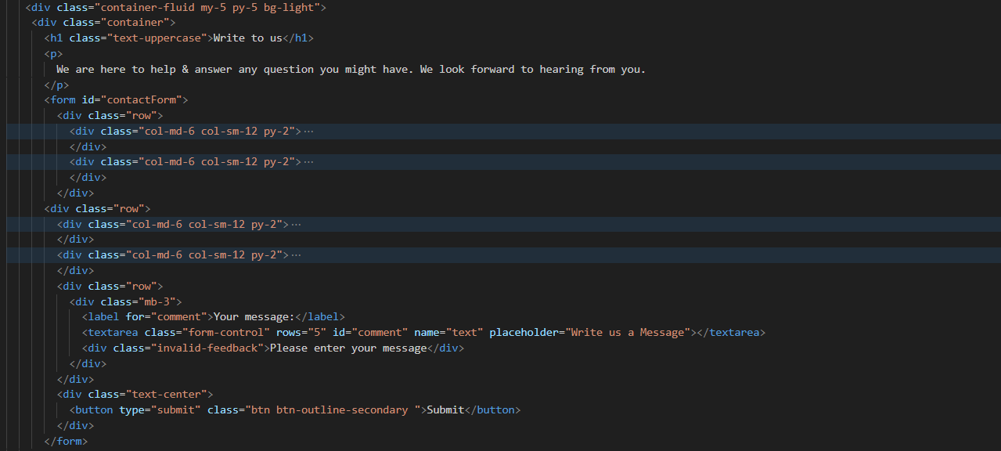

PHONE NUMBERS

PHONE NUMBERS CODE 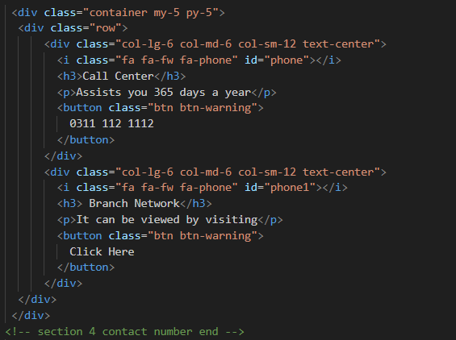

* CAREERS PAGE

HEADER SECTION



HEADER SECTION CODE

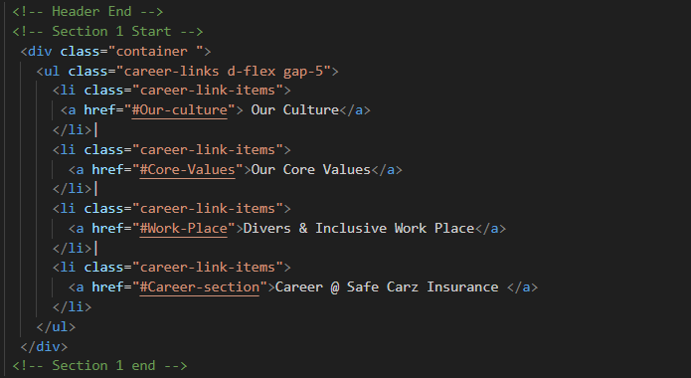

OUR CULTRE

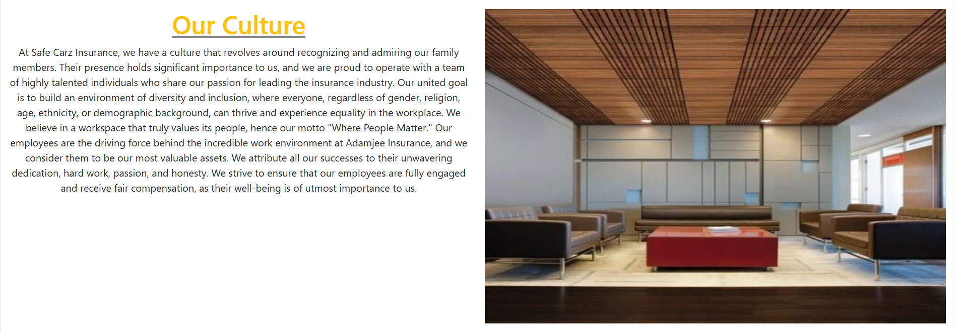

OUR CULTRE CODE

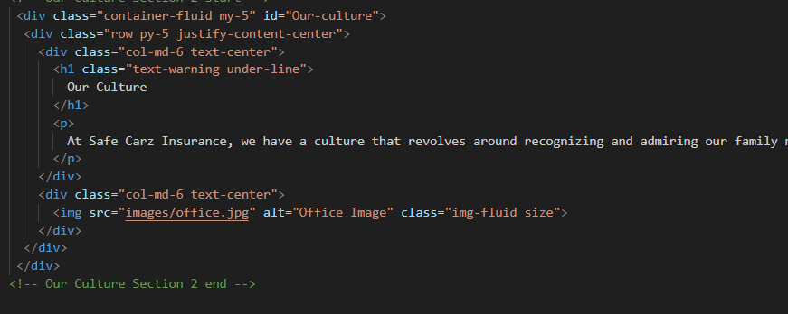

* Login Form Page

